Error Detection and Handling

- WAP to read atleast 2 designation strings from the user. Using assert validate
- Count of received designation strings
- Value of each string as one of {“E2”, “E3”, “E4”}
Failure of any of tested condition in i) or ii) should terminate program. On success should display the received valid designations
A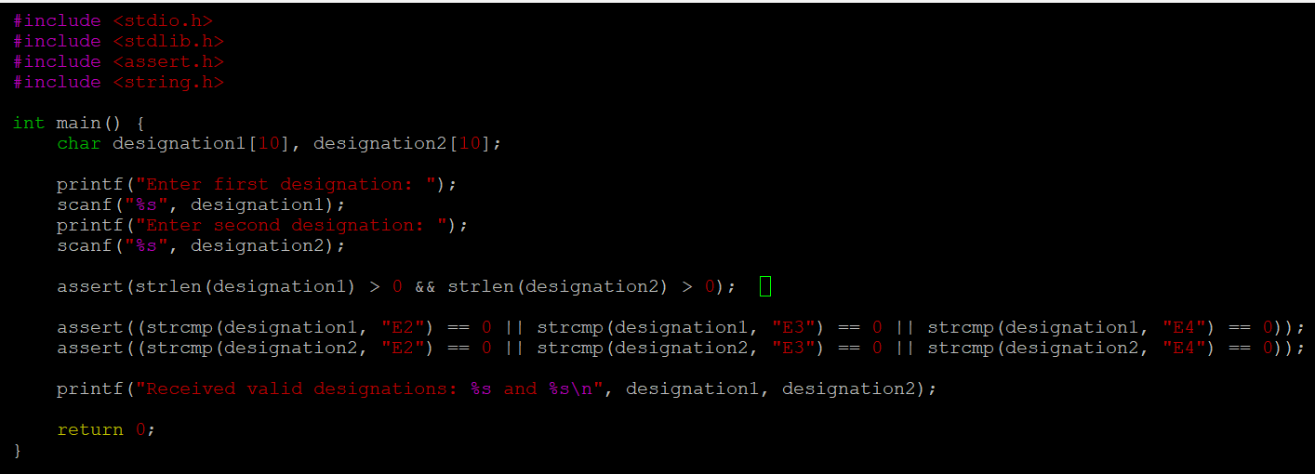
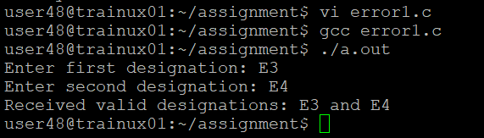
- Refer the code below. Modify code to use assert instead of if else. Add main and invoke function() and test it
void function(int x)
{
float fx;

if (x==0)
{
printf("Division by Zero is not allowed");
fprintf(stderr, "Division by zero! Exiting...\n");
exit(EXIT_FAILURE);
}
else
{
fx = 10 / x;
printf("f(x) is: %.5f", fx);
}
}
A:
